Rilla dashboard looks
Log in screen Shows all recordings for that location:
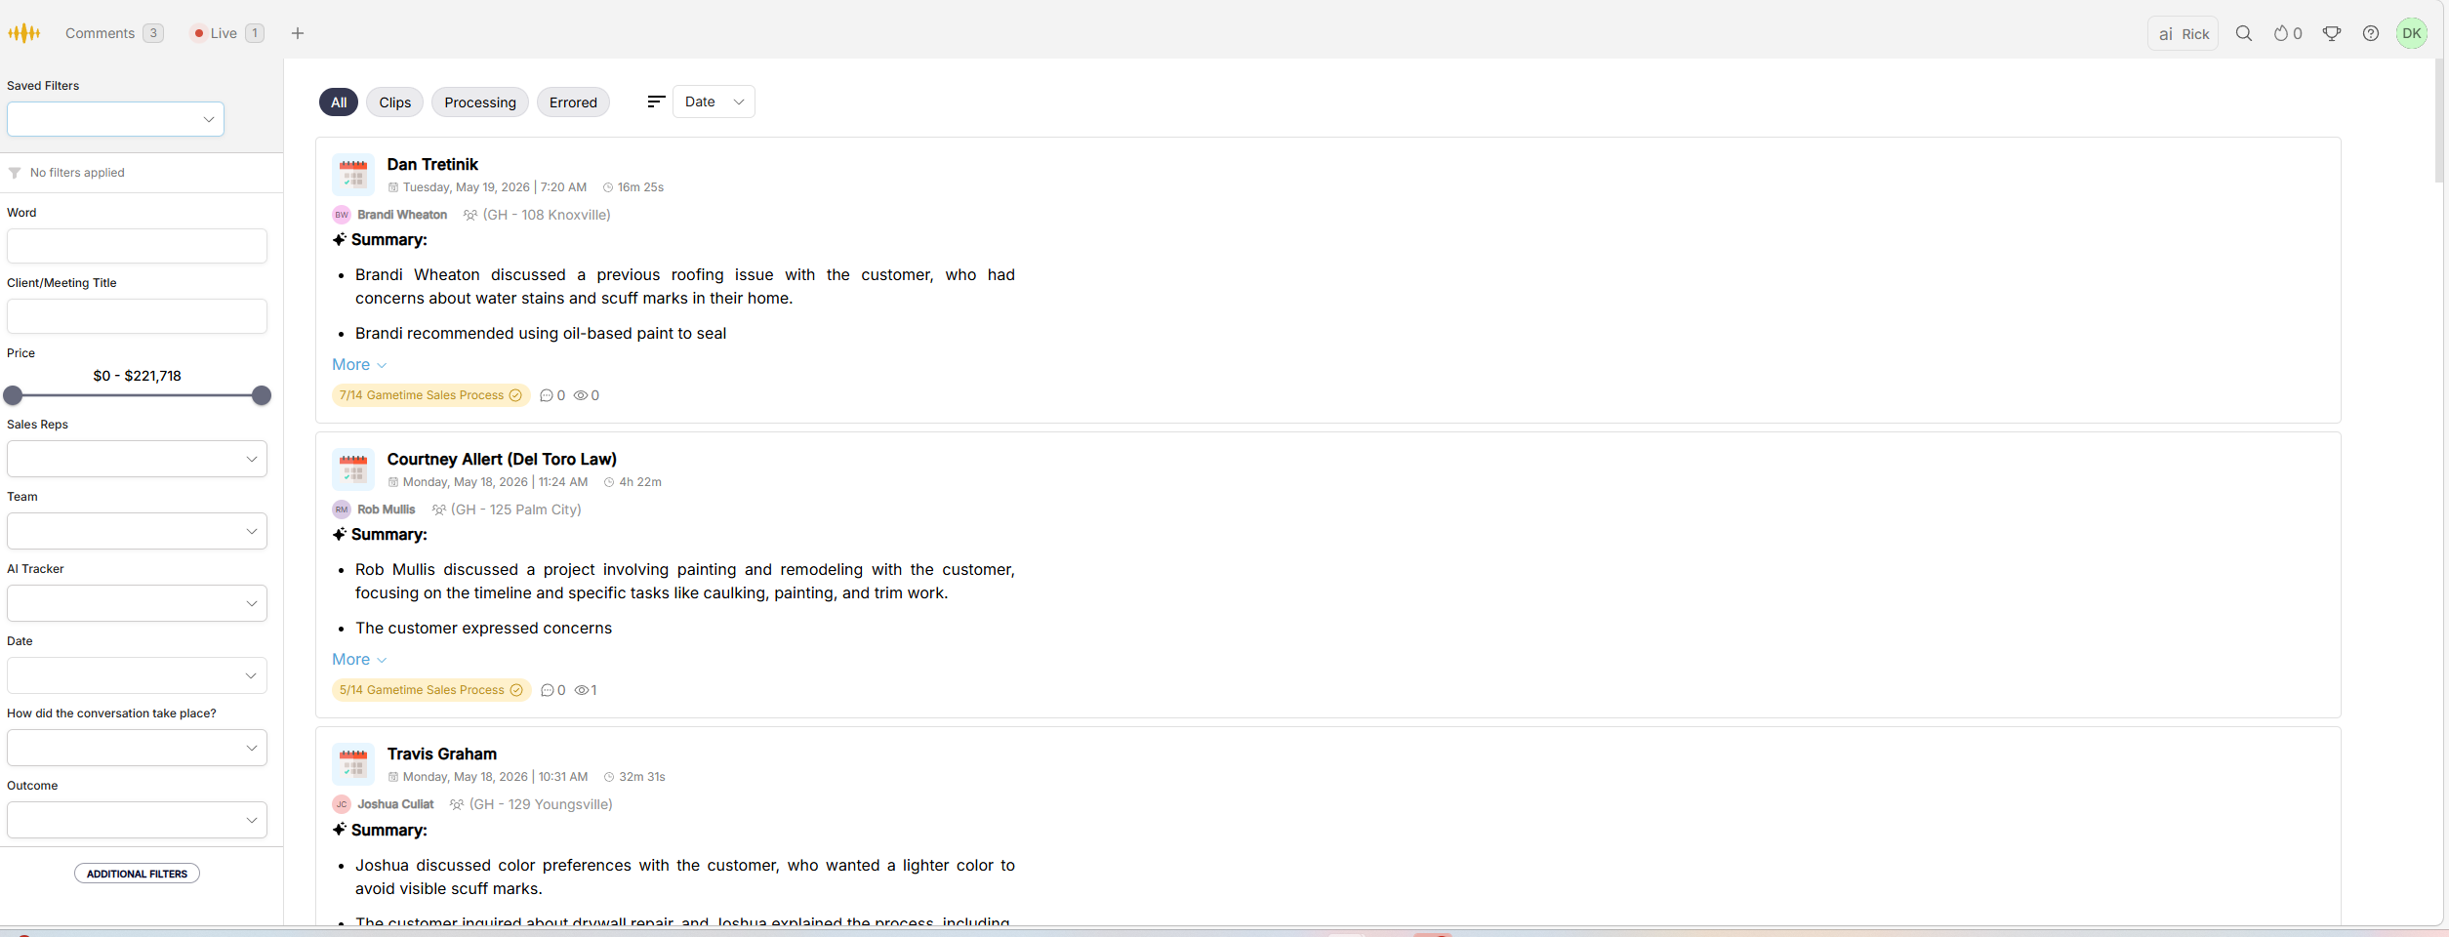

Click on Recording you get access to the Recording left side shows the Steps ours would be the 8 steps or customized. Top AI summary and Recording with transcript in the middle and bottome. Dan is the customers name we will want to make sure the DISC profile lives under the customer name. Brandi is the Sales Rep who did the recording when she started the recording date and time. 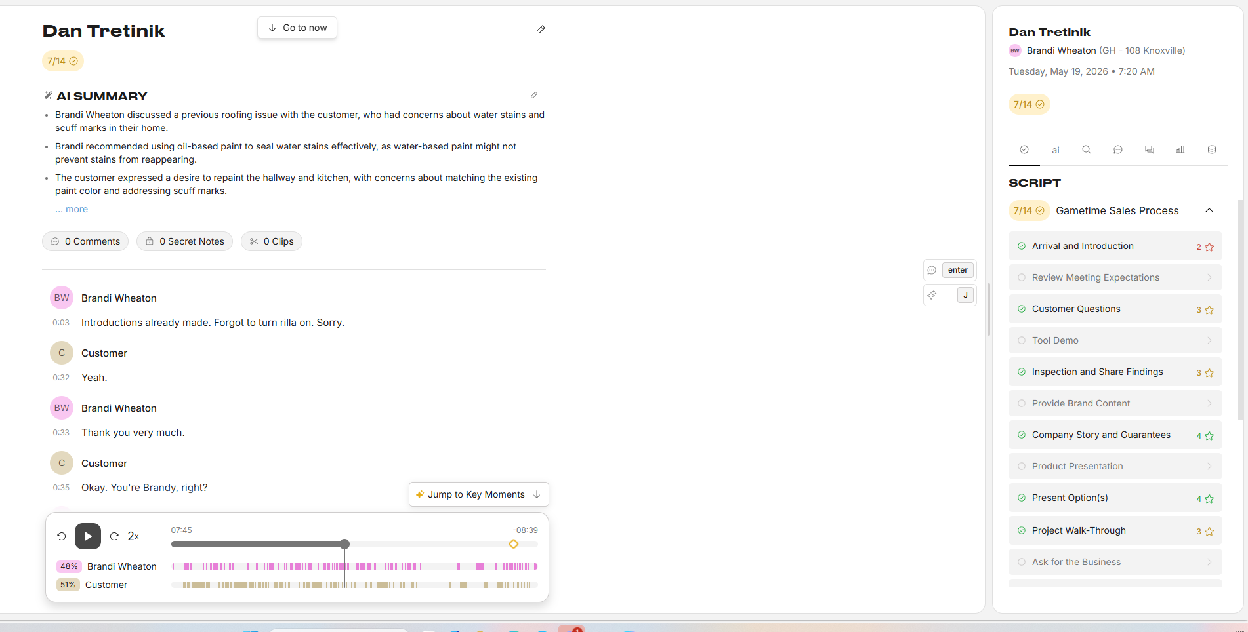
If you hit enter a manager can leave comments next to the transcipt for the sales person to review.
This is the picture where the AI would leave feedback on a section. 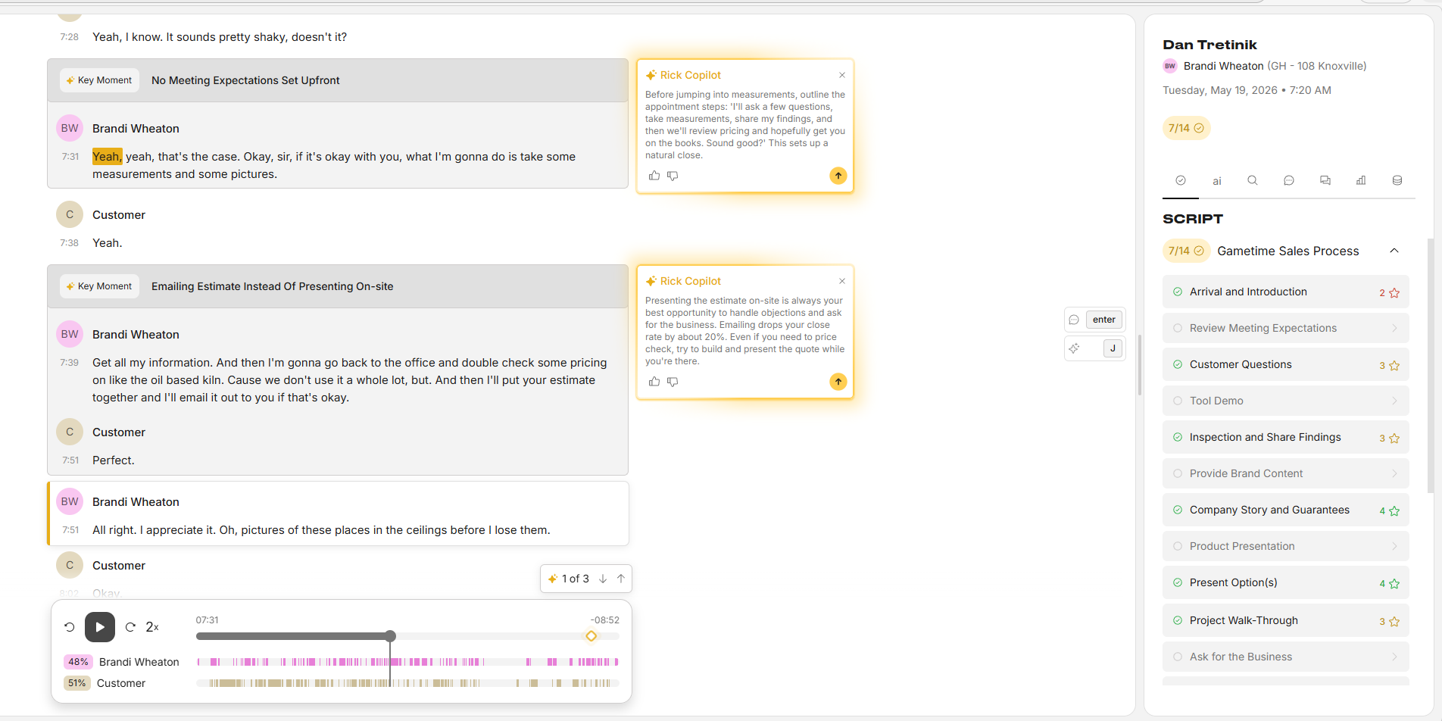
Gold Tringle in the recording shows those locations. 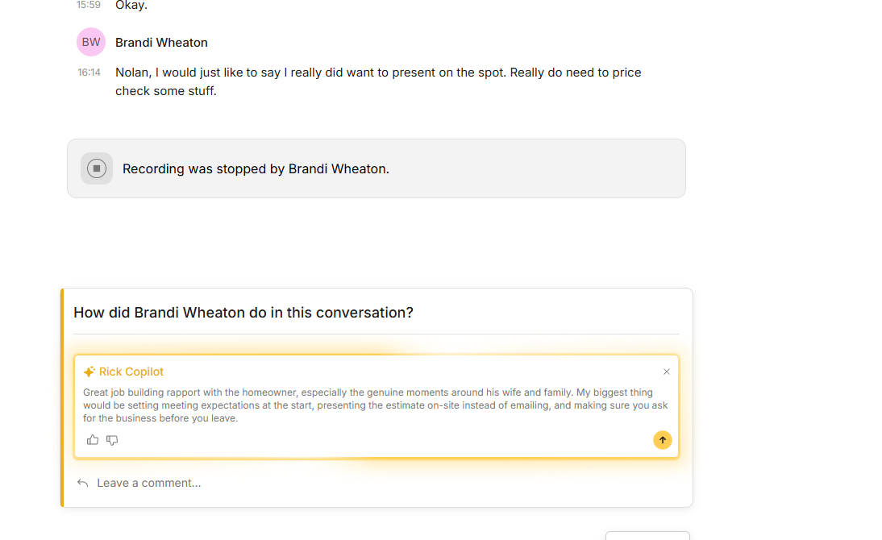
This would be at the bottom were we want the DISC profile to live for the customer and how the Rep did with the DISC profile.
This is how they are set up this is just some ideas. The front page we will want the different sections were they have a sidebar pop out. Again just some ideas nothing set in stone that I love about this.

